8/11/2018

Term Project

Online Pharmacy Store

Parth Chandgadhiya – 300986134

Hemil Patel - 300983675

Zoran Sarajlic

COMP 122

ER Diagram

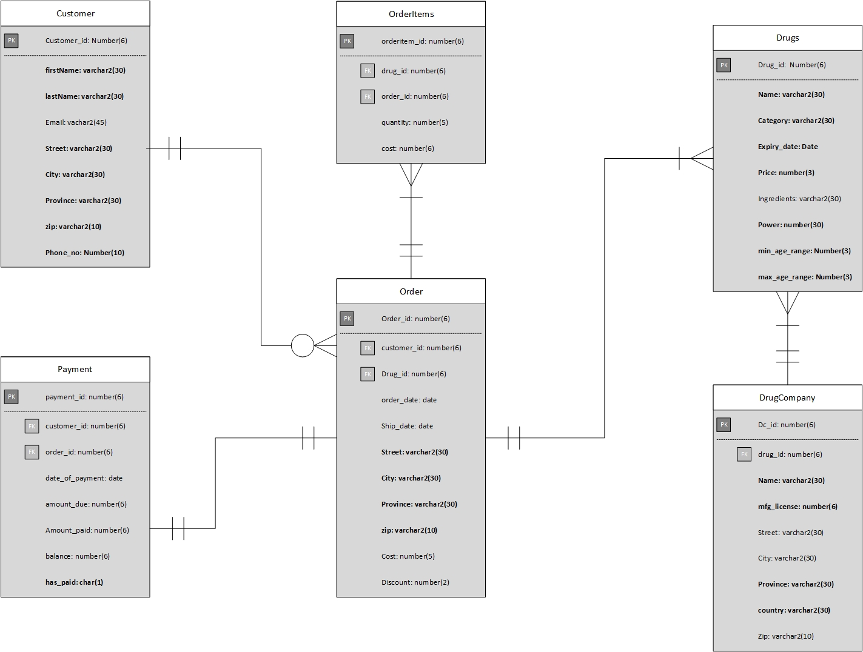

Table Design

# Customer map

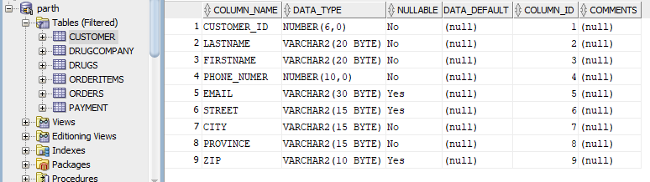

# Drugcompany map

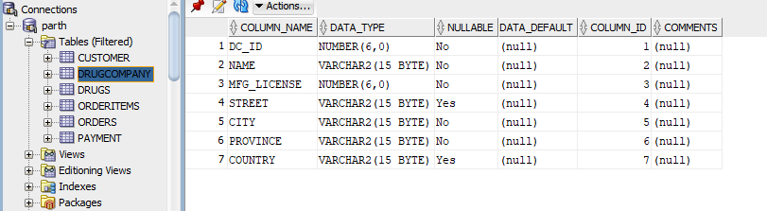

# Drugs map

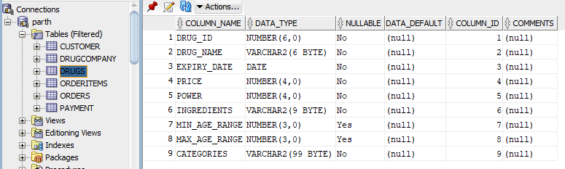

# Orderitem map

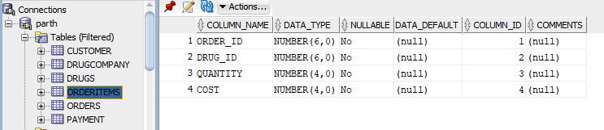

# Order map

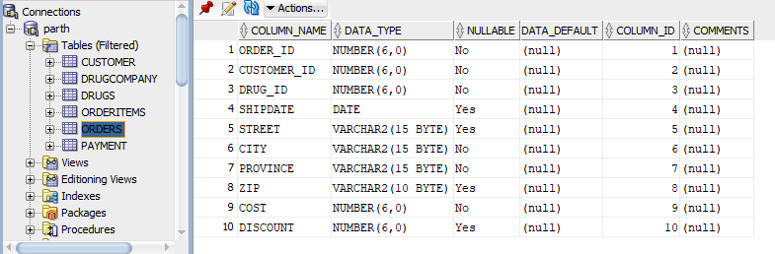

# Payment map

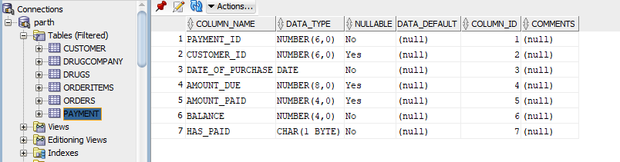

Table Constraints

# Customer

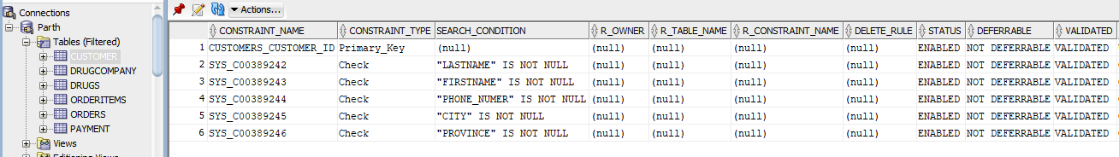

# DrugCompany

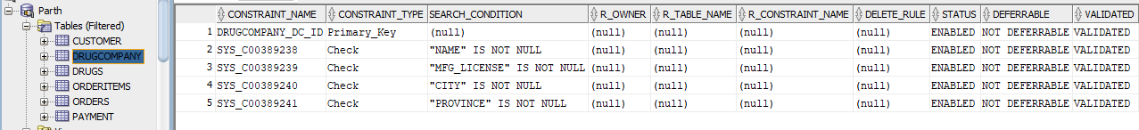

# Drugs

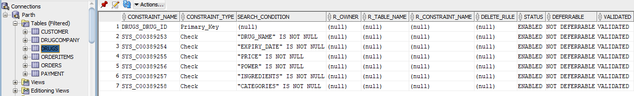

# Orderitems

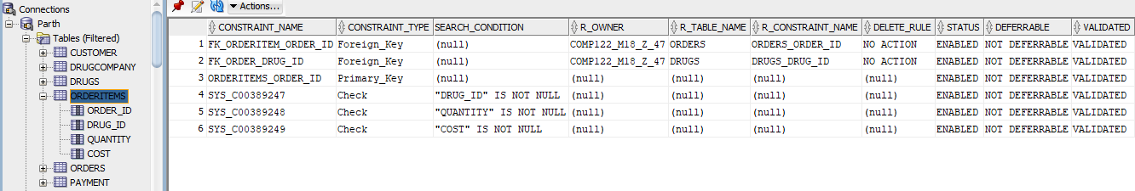

# Orders

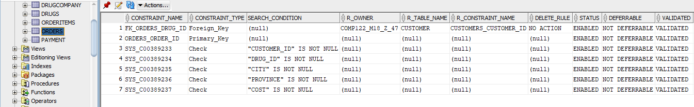

# Payment

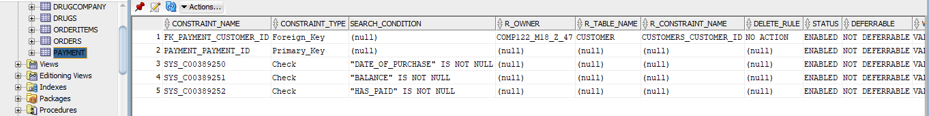

Table data

# Customers

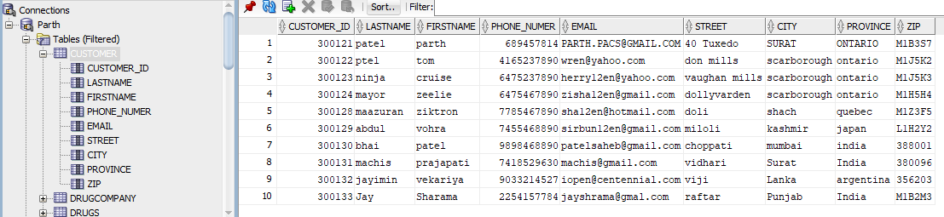

# DrugCompany

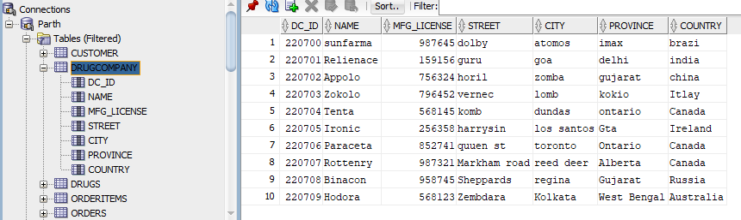

# Drugs

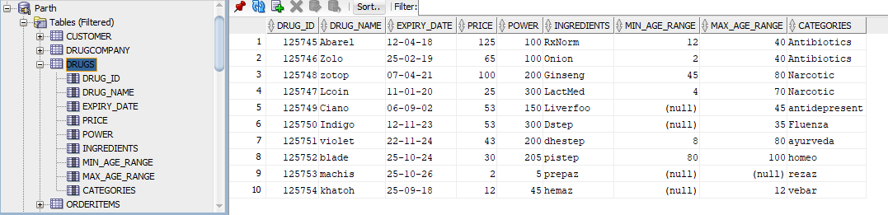

# Orders

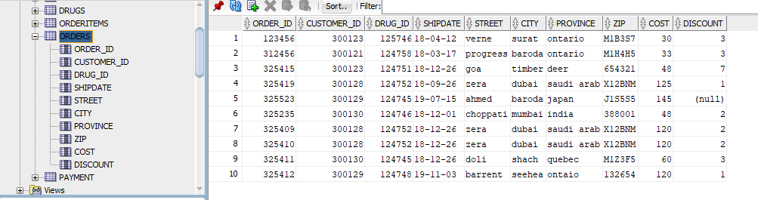

# Payment

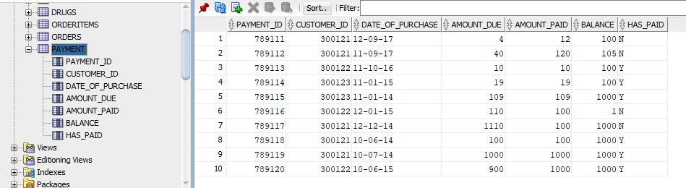

# OrderItems

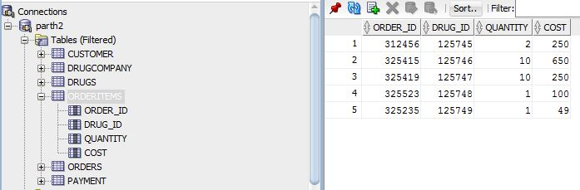

Queries

# 1) Joining the customer table with drugs table to find the name of customers who ordered drug with power greater than 150.

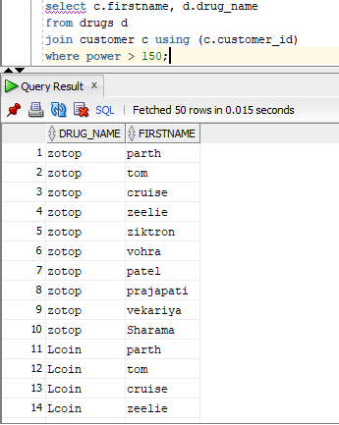

# 2) Getting the drug name, related order, and city to be shipped using left outer join

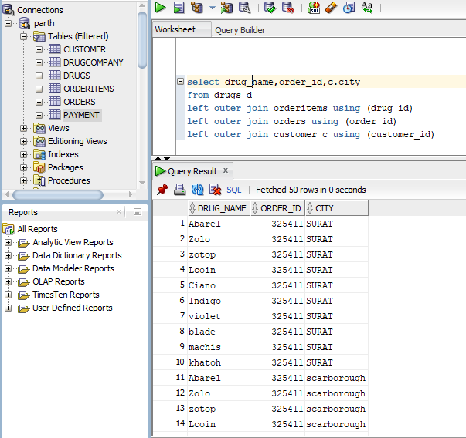

# 3) Getting the list of orders to be shipped after 1st April 2023.

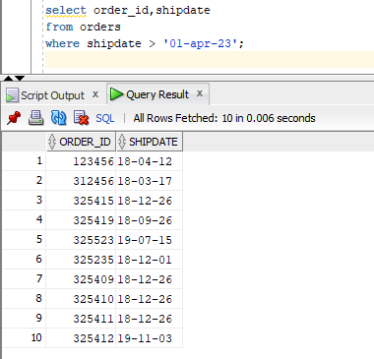

# 4) Getting the list of customers from Scarborough city and Ontario state

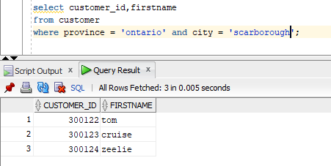

# 5) Query to get the customer who is from the city with ‘bai’ in its word and has purchased drugs worth more than $50.

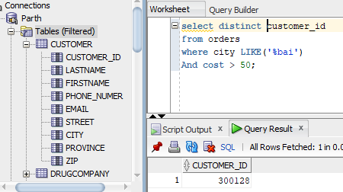

# 6) Getting the customer based on shipping date and street to be shipped

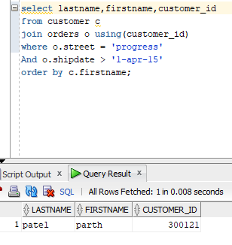

Project Code

Create table customer

(

customer_id Number(6,0),

lastName varchar2(20),

firstName varchar2(20),

email varchar2(30),

street varchar2(15),

city varchar2(15),

province varchar2(15),

zip varchar2(10),

phone_Numer number(10,0)

);

Create table drugCompany

(

dc_id number(6,0),

name varchar2(15)not null,

mfg_license number(6,0)not null,

street varchar2(15),

city varchar2(15) not null,

province varchar2(15)not null,

country varchar2(15)

);

Create table ORDERS

(

order_id Number(6,0),

customer_id Number(6,0) not null,

drug_id Number(6,0) not null,

shipdate date,

street varchar2(15),

city varchar2(15) not null,

province varchar2(15)not null,

zip varchar2(10),

cost number(6,0) not null,

discount number(6,0)

);

create table orderitems

(

order_id Number(6,0),

drug_id Number(6,0) not null,

quantity Number(4,0) not null,

cost Number (4,0)not null

);

create table payment

(

payment_id Number(6,0),

customer_id Number(6,0),

date_of_purchase date not null,

Amount_due Number(8,0),

Amount_paid Number(4,0),

balance Number (4,0)not null,

has_paid char(1) not null

);

create table drugs

(

drug_id Number(6,0),

drug_name varchar2(6),

expiry_date date,

price Number(4,0),

power Number(4,0),

ingredients varchar2(9),

min_age_range number (3,0),

max_age_range number (3,0),

categories varchar(99)

);

alter table orders

add CONSTRAINT orders_order_id primary key(order_id);

alter table drugs

add CONSTRAINT drugs_drug_id primary key(drug_id);

alter table customer

add CONSTRAINT customers_customer_id primary key(customer_id);

alter table drugcompany

add CONSTRAINT drugcompany_dc_id primary key(dc_id);

alter table payment

add CONSTRAINT payment_payment_id primary key(payment_id);

ALTER TABLE Orderitems

ADD CONSTRAINT FK_order_drug_id

FOREIGN KEY (drug_id) REFERENCES drugs(drug_ID);

ALTER TABLE orders

ADD CONSTRAINT FK_orders_drug_id

FOREIGN KEY (customer_id) REFERENCES customer(customer_id);

ALTER TABLE payment

ADD CONSTRAINT FK_payment_customer_id

FOREIGN KEY (order_id) REFERENCES orders(order_id);

ALTER TABLE Orders

ADD CONSTRAINT FK_order_customer_id

FOREIGN KEY (customer_id) REFERENCES orders(customer_ID);

insert into customer(customer_id,lastname,firstname,phone_numer,email,street,city,province,zip)

VALUES ('300122','ptel','tom','4165237890','wren@yahoo.com','don mills','scarborough','ontario','M1J5K2');

insert into customer(customer_id,lastname,firstname,phone_numer,email,street,city,province,zip)

VALUES ('300123','ninja','cruise','6475237890','herry12en@yahoo.com','vaughan mills','scarborough','ontario','M1J5K3');

insert into customer(customer_id,lastname,firstname,phone_numer,email,street,city,province,zip)

VALUES ('300124','mayor','zeelie','6475467890','zisha12en@gmail.com','dollyvarden','scarborough','ontario','M1H5H4');

insert into customer(customer_id,lastname,firstname,phone_numer,email,street,city,province,zip)

VALUES ('300125','brahmbhatt','jay','6475469874','zisha1@outlook.com','tuxedo','surat','ontario','300986');

insert into customer(customer_id,lastname,firstname,phone_numer,email,street,city,province,zip)

VALUES ('300126','maaz','woran','4165415587','jaja@hotmail.com','milner','suratimar','vietnam','L1S5S5');

insert into customer(customer_id,lastname,firstname,phone_numer,email,street,city,province,zip)

VALUES ('300127','kathan','woema','7785415587','raja@gmail.com','ahmed','baroda','japan','J1S5S5');

insert into customer(customer_id,lastname,firstname,phone_numer,email,street,city,province,zip)

VALUES ('300128','maazuran','ziktron','7785467890','sha12en@hotmail.com','doli','shach','quebec','M1Z3F5');

insert into customer(customer_id,lastname,firstname,phone_numer,email,street,city,province,zip)

VALUES ('300129','abdul','vohra','7455468890','sirbun12en@gmail.com','miloli','kashmir','japan','L1H2Y2');

insert into customer(customer_id,lastname,firstname,phone_numer,email,street,city,province,zip)

VALUES ('300130','bhai','patel','9898468890','patelsaheb@gmail.com','choppati','mumbai','india','388001');

insert into customer(customer_id,lastname,firstname,phone_numer,email,street,city,province,zip)

VALUES ('300132','jayimin','vekariya','9033214527','iopen@centennial.com','viji','Lanka','argentina','356203');

insert into customer(customer_id,lastname,firstname,phone_numer,email,street,city,province,zip)

VALUES ('300133','Jay','Sharama','2254157784','jayshrama@gmal.com','raftar','Punjab','India','M1B2M3');

insert into orders(order_id,customer_id,drug_id,shipdate,street,city,province,zip,cost,discount)

VALUES (312456,300121,124758,'18-mar-17','progress','baroda','ontario','M1H4H5','33','3');

insert into orders(order_id,customer_id,drug_id,shipdate,street,city,province,zip,cost,discount)

VALUES (325415,300123,124751,'18-dec-26','goa','timber','deer','654321','48','7');

insert into orders(order_id,customer_id,drug_id,shipdate,street,city,province,zip,cost,discount)

VALUES (325419,300128,124752,'18-sep-26','zera','dubai','saudi arab','X12BNM','125','1');

insert into orders(order_id,customer_id,drug_id,shipdate,street,city,province,zip,cost,discount)

VALUES (325523,300129,124745,'19-jul-15','ahmed','baroda','japan','J1S5S5','145','');

insert into orders(order_id,customer_id,drug_id,shipdate,street,city,province,zip,cost,discount)

VALUES (325235,300130,124746,'18-dec-1','choppati','mumbai','india','388001','48','2');

insert into orders(order_id,customer_id,drug_id,shipdate,street,city,province,zip,cost,discount)

VALUES (325411,300127,124745,'18-dec-26','doli','shach','quebec','M1Z3F5','60','3');

insert into orders(order_id,customer_id,drug_id,shipdate,street,city,province,zip,cost,discount)

VALUES (325491,300125,124752,'19-nov-03','barrent','seehea','ontaio','132654','150','1');

insert into orders(order_id,customer_id,drug_id,shipdate,street,city,province,zip,cost,discount)

VALUES (325482,300128,124746,'18-nov-03','tempa','oak land','ontario','M1N2K6','20','8');

insert into orders(order_id,customer_id,drug_id,shipdate,street,city,province,zip,cost,discount)

VALUES (325478,300126,124751,'19-oct-21','Elldemere','london','ontaio','M4K9U8','70','2');

insert into orders(order_id,customer_id,drug_id,shipdate,street,city,province,zip,cost,discount)

VALUES (325493,300129,124748,'19-dec-25','milner','suratimar','vietnam','654798','112','1');

insert into drugcompany(dc_id,name,mfg_license,street,city,province,country)

values('220700','sunfarma','987645','dolby','atomos','imax','brazi');

insert into drugcompany(dc_id,name,mfg_license,street,city,province,country)

values('220701','Relienace','159156','guru','goa','delhi','india');

insert into drugcompany(dc_id,name,mfg_license,street,city,province,country)

values('220702','Appolo','756324','horil','zomba','gujarat','china');

insert into drugcompany(dc_id,name,mfg_license,street,city,province,country)

values('220703','Zokolo','796452','vernec','lomb','kokio','Itlay');

insert into drugcompany(dc_id,name,mfg_license,street,city,province,country)

values('220704','Tenta','568145','komb','dundas','ontario','Canada');

insert into drugcompany(dc_id,name,mfg_license,street,city,province,country)

values('220705','Ironic','256358','harrysin','los santos','Gta','Ireland');

insert into drugcompany(dc_id,name,mfg_license,street,city,province,country)

values('220706','Paraceta','852741','quuen st','toronto','Ontario','Canada');

insert into drugcompany(dc_id,name,mfg_license,street,city,province,country)

values('220707','Rottenry','987321','Markham road','reed deer','Alberta','Canada');

insert into drugcompany(dc_id,name,mfg_license,street,city,province,country)

values('220708','Binacon','958745','Sheppards','regina','Gujarat','Russia');

insert into drugcompany(dc_id,name,mfg_license,street,city,province,country)

values('220709','Hodora','568123','Zembdara','Kolkata','West Bengal','Australia');

insert into customer(customer_id,lastname,firstname,phone_numer,email,street,city,province,zip)

VALUES ('300122','ptel','tom','4165237890','wren@yahoo.com','don mills','scarborough','ontario','M1J5K2');

insert into customer(customer_id,lastname,firstname,phone_numer,email,street,city,province,zip)

VALUES ('300123','ninja','cruise','6475237890','herry12en@yahoo.com','vaughan mills','scarborough','ontario','M1J5K3');

insert into customer(customer_id,lastname,firstname,phone_numer,email,street,city,province,zip)

VALUES ('300124','mayor','zeelie','6475467890','zisha12en@gmail.com','dollyvarden','scarborough','ontario','M1H5H4');

insert into customer(customer_id,lastname,firstname,phone_numer,email,street,city,province,zip)

VALUES ('300125','brahmbhatt','jay','6475469874','zisha1@outlook.com','tuxedo','surat','ontario','300986');

insert into customer(customer_id,lastname,firstname,phone_numer,email,street,city,province,zip)

VALUES ('300126','maaz','woran','4165415587','jaja@hotmail.com','milner','suratimar','vietnam','L1S5S5');

insert into customer(customer_id,lastname,firstname,phone_numer,email,street,city,province,zip)

VALUES ('300127','kathan','woema','7785415587','raja@gmail.com','ahmed','baroda','japan','J1S5S5');

insert into customer(customer_id,lastname,firstname,phone_numer,email,street,city,province,zip)

VALUES ('300128','maazuran','ziktron','7785467890','sha12en@hotmail.com','doli','shach','quebec','M1Z3F5');

insert into customer(customer_id,lastname,firstname,phone_numer,email,street,city,province,zip)

VALUES ('300129','abdul','vohra','7455468890','sirbun12en@gmail.com','miloli','kashmir','japan','L1H2Y2');

insert into customer(customer_id,lastname,firstname,phone_numer,email,street,city,province,zip)

VALUES ('300130','bhai','patel','9898468890','patelsaheb@gmail.com','choppati','mumbai','india','388001');

insert into DRUGS(drug_id, drug_name, expiry_date, price, power, ingredients ,min_age_range, max_age_range,categories)

values

(125746,'Zolo','19-feb-25','65','100','Onion','2','40','Antibiotics');

insert into DRUGS(drug_id, drug_name, expiry_date, price, power, ingredients ,min_age_range, max_age_range,categories)

values

(125747,'Lcoin','20-jan-11','25','300','LactMed','4','70','Narcotic');

insert into DRUGS(drug_id, drug_name, expiry_date, price, power, ingredients ,min_age_range, max_age_range,categories)

values

(125748,'zotop','21-Apr-7','100','200','Ginseng','45','80','Narcotic');

insert into DRUGS(drug_id, drug_name, expiry_date, price, power, ingredients ,min_age_range, max_age_range,categories)

values

(125749,'Ciano','2-Sep-6','53','150','Liverfoo','','45','antidepresent');

insert into DRUGS(drug_id, drug_name, expiry_date, price, power, ingredients ,min_age_range, max_age_range,categories)

values

(125750,'Indigo','23-nov-12','53','300','Dstep','','35','Fluenza');

insert into DRUGS(drug_id, drug_name, expiry_date, price, power, ingredients ,min_age_range, max_age_range,categories)

values

(125751,'violet','24-nov-22','43','200','dhestep','8','80','ayurveda');

insert into DRUGS(drug_id, drug_name, expiry_date, price, power, ingredients ,min_age_range, max_age_range,categories)

values

(125752,'blade','24-oct-25','30','205','pistep','80','100','homeo');

insert into DRUGS(drug_id, drug_name, expiry_date, price, power, ingredients ,min_age_range, max_age_range,categories)

values

(125753,'machis','26-oct-25','2','5','prepaz','','','rezaz');

insert into DRUGS(drug_id, drug_name, expiry_date, price, power, ingredients ,min_age_range, max_age_range,categories)

values

(125754,'khatoh','18-sep-25','12','45','hemaz','','12','vebar');

insert into payment( payment_id , customer_id , date_of_purchase , amount_due , amount_paid , balance ,has_paid)

values('789112','300121','17-sep-11','40','120','105','N');

insert into payment( payment_id , customer_id , date_of_purchase , amount_due , amount_paid , balance ,has_paid)

values('789113','300122','16-oct-11','10','10','100','Y');

insert into payment( payment_id , customer_id , date_of_purchase , amount_due , amount_paid , balance ,has_paid)

values('789114','300123','15-JAN-11','19','19','100','Y');

insert into payment( payment_id , customer_id , date_of_purchase , amount_due , amount_paid , balance ,has_paid)

values('789115','300123','14-JAN-11','109','109','1000','Y');

insert into payment( payment_id , customer_id , date_of_purchase , amount_due , amount_paid , balance ,has_paid)

values('789116','300122','14-JAN-112','110','100','1','N');

insert into payment( payment_id , customer_id , date_of_purchase , amount_due , amount_paid , balance ,has_paid)

values('789117','300121','14-dec-12','1110','100','1000','N');

insert into payment( payment_id , customer_id , date_of_purchase , amount_due , amount_paid , balance ,has_paid)

values('789118','300121','14-jun-10','100','100','1000','Y');

insert into payment( payment_id , customer_id , date_of_purchase , amount_due , amount_paid , balance ,has_paid)

values('789119','300121','14-jul-10','1000','1000','1000','Y');

insert into payment( payment_id , customer_id , date_of_purchase , amount_due , amount_paid , balance ,has_paid)

values('789120','300122','15-jun-10','900','1000','1000','Y');

insert into payment( payment_id , customer_id , date_of_purchase , amount_due , amount_paid , balance ,has_paid)

values('789121','300123','18-Mar-8','900','10','100','Y');

insert into orderitems (order_id, drug_id ,quantity , cost)

values(312456,'125745','2','66');

insert into orderitems (order_id, drug_id ,quantity , cost)

values(325419,'125747','10','250');

insert into orderitems (order_id, drug_id ,quantity , cost)

values(325523,'125748','1','100');

insert into orderitems (order_id, drug_id ,quantity , cost)

values(325235,'125749','1','49');

insert into orderitems (order_id, drug_id ,quantity , cost)

values(325411,'125750','10','530');

insert into orderitems (order_id, drug_id ,quantity , cost)

values(327523,'125748','1','100');

insert into orderitems (order_id, drug_id ,quantity , cost)

values(312426,'125745','2','66');

insert into orderitems (order_id, drug_id ,quantity , cost)

values(325439,'125747','1','25');

insert into orderitems (order_id, drug_id ,quantity , cost)

values(327235,'125749','3','49');

insert into orderitems (order_id, drug_id ,quantity , cost)

values(327411,'125750','1','53');

insert into orderitems (order_id, drug_id ,quantity , cost)

values(312456,'125745','2','66');

insert into orderitems (order_id, drug_id ,quantity , cost)

values(325419,'125747','10','250');

insert into orderitems (order_id, drug_id ,quantity , cost)

values(325523,'125748','1','100');

insert into orderitems (order_id, drug_id ,quantity , cost)

values(325235,'125749','1','49');

insert into orderitems (order_id, drug_id ,quantity , cost)

values(325411,'125750','10','530');